**DECLARATION BY THE VAIDEHI GHODASARA**

I hereby declare that the project report entitled **QR-Code based Feedback Form System** submitted by me to Chandubhai S. Patel Institute of Technology, Changa in partial fulfilment of the requirements for the award of the degree of **B.Tech** **Computer Science & Engineering**, from Department of Computer Science & Engineering, CSPIT, FTE, is a record of bonafide CE255 Software group Project-II carried out by me under the guidance of Vaibhavi Patel . further declare that the work carried out and documented in this project report has not been submitted anywhere else either in part or in full and it is the original work, for the award of any other degree or diploma in this institute or any other institute or university.

**Vaidehi Ghodasara(21CS011)**

This is to certify that the above statement made by the candidate is correct to the best of my knowledge.

Prof. Vaibhavi Patel

Assistant Proffessor

Department of Computer Science & Engineering,

Chandubhai S Patel Institute of Technology (CSPIT)

Faculty of Technology (FTE)

Charotar University of Science and Technology (CHARUSAT) - Changa.

**Abstract**

We know that a feedback system is very important for system improvement. Therefore we created a QR-Code based police feedback system for citizens so that they can easily give feedback about what they feel and help the police to improve. Using this feedback police can easily track their mistakes and can easily improve them. This genuine feedback from the public is very important for the system if the feedback is negative then it indicated that the police station has to be more proper in service and the government can easily check the progress of that particular station

**Acknowledgement**

We would like to express our gratitude to all the individuals and organizations that supported us throughout this project.

Firstly, we would like to thank our project supervisor for “**Prof. Vaibhavi Patel** ” mam’s guidance, support, and valuable feedback throughout the project. His advice helped us to make the right decisions and stay on track.

We would also like to extend our thanks to the faculty of **Chandubhai S. Patel Institute of Technology** for providing us with the resources and facilities necessary for carrying out the project successfully.

We would like to thank our family and friends for their understanding and encouragement throughout the project. They provided us with the necessary motivation and support to keep going even during challenging times.

Finally, we would like to thank all the participants who took part in the project, providing us with valuable insights and feedback. Without their participation, this project would not have been possible.

Thank you all for your contribution and support. We appreciate your efforts and would like to express our heartfelt thanks to each and every one of you.

**Table of Contents**

Chapter -1: Introduction ---------------------------------------------------------------------1

* 1. Project Summary
  2. Purpose
  3. Scope
  4. Objective
  5. Technology

Chapter -2: Project Management

2.1 Project Planning

2.1.1 Project Development Approach and Justification

2.1.2 Roles and Responsibilities

2.2 Project Scheduling (Gantt Chart)

Chapter -3: System Requirement Study

* 1. User Characteristics (Type of users who is dealing with the system)
  2. Hardware and Software Requirements (minimum requirements to run your system)

Chapter -4: System Analysis

* 1. Study of Current System
  2. Problem and Weaknesses of Current System
  3. Requirements of New System
     1. Functional Requirement
     2. Non Functional Requirements
  4. Data Modelling
     1. E/R Diagram
  5. List Main Modules of New System Conclusion
  6. Flow diagram/Flow Chart

Chapter – 5: System Design

* 1. System Application Design

5.1.1 Method Pseudo Code

* 1. Database Design/Data Structure Design
     1. Data Dictionary
  2. Input/output and Interface Design (Sample of Forms, Reports and Interface)

Chapter – 6: Conclusion and Discussion

References

**CHAPTER - 1 : INTRODUCTION**

* 1. **PROJECT SUMMARY**

We know that a feedback system is very important for system improvement. Therefore we create a QR-based police feedback system for citizens so that they can easily give feedback about what they feel and help the police to improve. Using this feedback police can easily track their mistakes and can easily improve them. This genuine feedback from the public is very important for the system if the feedback is negative then it indicated that the police station has to be more proper in service and the government can easily check the progress of that particular station

* 1. **Purpose**
* So the other alternative is—creating a digital form and getting your audience to fill it. And to do that, you can add the link to the form on your invoices, marketing creatives, etc.
* In our case the feedback form is for police officer and the police station.
* So in this people can easily give the responses of a police officer or a police station. After that police can analyze the responses of all the people and they can improve their system or they can find what they are doing wrong so they can improve.

Overall, the primary goal of a qr code base feedback form system is to improve the fast reply to the people

* 1. **SCOPE**
* Citizens can easily give feedback. mobile web browser-based interface.
* Officers can get details of quality of service of any police station by analysis of data. web based interface for police officers.
* Citizens will get better behavior of police and faster response from police in due course of time.

* 1. **TECHNOLOGY**
* Front-end : HTML, CSS,
* Back-end : PHP,firebase

**Chapter 2 -Project Management**

**2.1 Project Planning**

|  |  |
| --- | --- |
| Week 1 | Problem Definition Submission |
| Week 2 | Formulate Flow diagram, Work Background Structure, Timeline |
| Week 3 | Implementation of UI/UX Design |
| Week 4 | Implementation of UI/UX Design |
| Week 5 | Implementation of UI/UX Design |
| Week 6 | Implementation of Backend(user input form) |
| Week 7 | Implementation of Backend(user input form) |
| Week 8 | Implementation of Backend(user input form) |
| Week 9 | Implementation of Backend(user input form) |
| Week 10 | Implementation of Backend(user input form) |
| Week 11 | Implementation of backend(pie chart formulation) |
| Week 12 | Implementation of backend(pie chart formulation) |
| Week 13 | Implementation of backend(pie chart formulation) |
| Week 14 | Report Writing |
| Week 15 | Report Writing |
| Week 16 | Upgrating validation in form |
| Week 17 | Upgrating validation in backend |

**CHAPTER - 3: SYSTEM REQUIREMENT STUDY**

**3.1 USER CHARACTERISTICS (TYPE OF USERS WHO IS DEALING WITH THE SYSTEM)**

* citizen:

fill the form for the any problem

* police officer:

solve the all problem of the citizen

* Admin:

See all the all the problem of the citizen.

See how many forms is filled by the citizen.

**3.2 Software Requirement**

Web Server: A web server software such as Apache, Nginx, or IIS is required to host website. The Choice of web server software depends on the operating system and the programming language used to Develop the website.

Operating System: The operating system (OS) on the server must be compatible with the web server Software and the programming languages used for the website. Common server operating systems Include Windows Server, Linux, and UNIX.

Programming Languages: Websites can be developed using a variety of programming languages such as HTML, CSS, JavaScript, PHP, and more. The programming languages used for a website depend on the website's requirements and the developer's preferenc

**CHAPTER - 4: SYSTEM ANALYSIS**

**4.1 STUDY OF CURRENT SYSTEM**

The study says that it works good and it realease the pressure of work on police force

**4.2 PROBLEM AND WEAKNESS OF CURRENT SYSTEM**

Technical Issues:

One of the main problems associated with QR code base feedback form systems is technical issues. These issues can arise due to system glitches, network failures, and hardware or software malfunctions. Technical problems can result in system downtime, which can affect the hotel's operations and cause inconvenience to guests.

User interface Problems:

The user interface of the QR code base feedback form system should be easy to use and navigate. If it's complicated, users may have difficulty accessing and using the system, leading to inefficiencies.

Data entry Errors:

Manual data entry is prone to errors that can result in incorrect information being entered into the system. These errors can lead to operational inefficiencies and customer dissatisfaction.

**4.3 REQUIREMENT OF NEW SYSTEM**

**4.3.1 FUNCTIONAL REQUIREMENT**

HOME LAYOUT : Home page including old and new logo of Police. Also accommodates

navigation bar which comprises link of of home module, feedback form , admin access module, venue/location module, query/help

module

FEEDBACK FORM MODULE : It consists of user input mobile number and otp is sent which is then verified by entering otp. Then

feedform is seen and filled up by user.

ADMIN ACCESS MODULE : The form details is shown in form of pie-chart

LOCALITY/VENUE MODULE : It displays the location of police station.

QUERY/HELP MODULE : It helps to contact police by online mode

**4.3.2 NON FUNCTIONAL REQUIREMENT**

We can add every state police system foe this feedback

**4.6 Flow DIAGRAM**

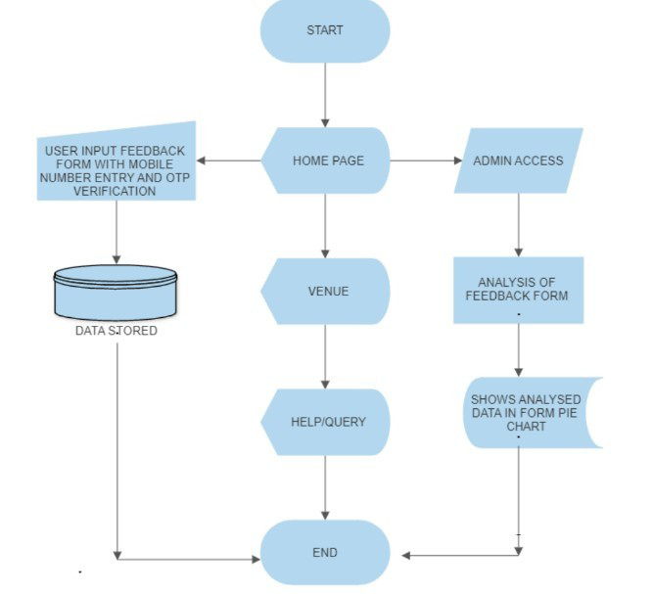

**Chapter 5 SYSTEM DESIGN**

**5.3 INPUT/OUTPUT INTERFACE DESIGN**

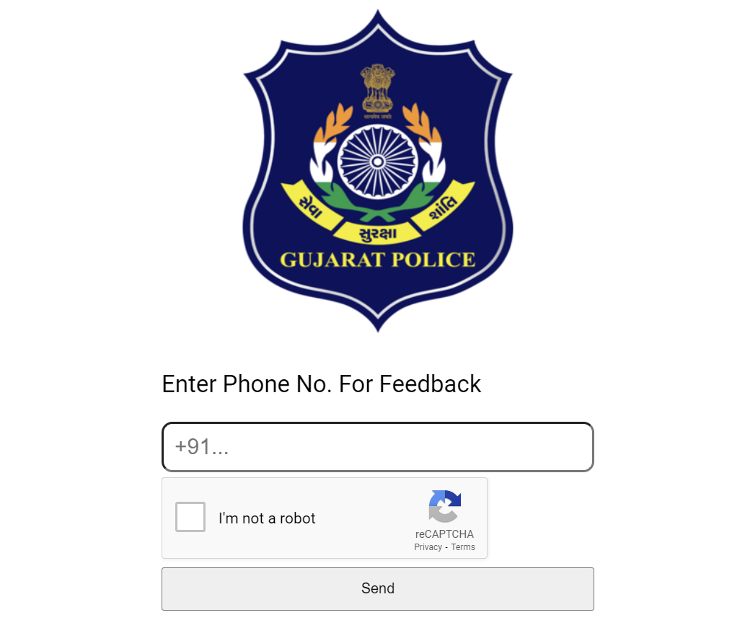

Fig. Login Authentication

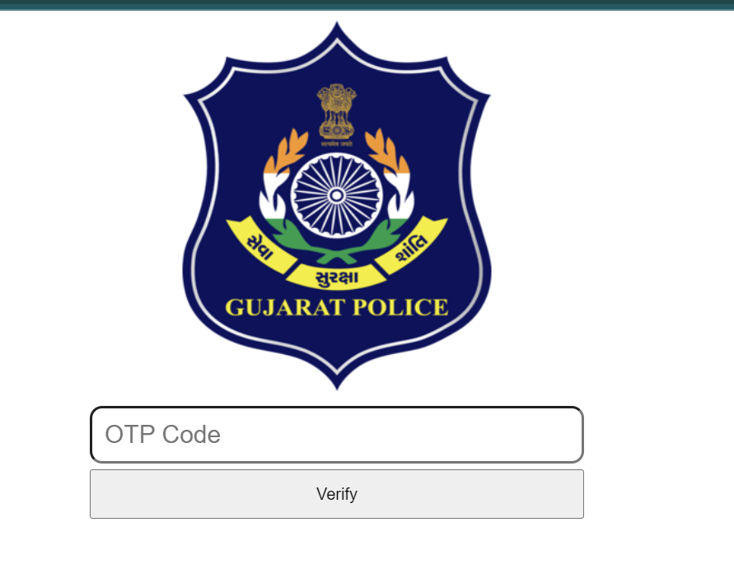

Fig. OTP Verification

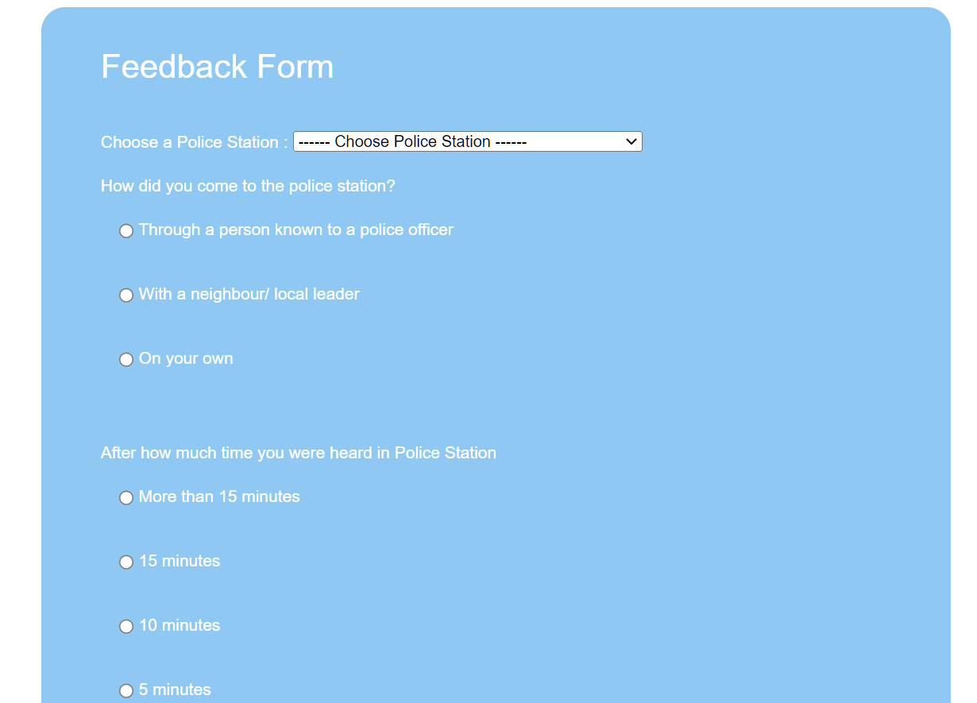

Fig. Feedback Form

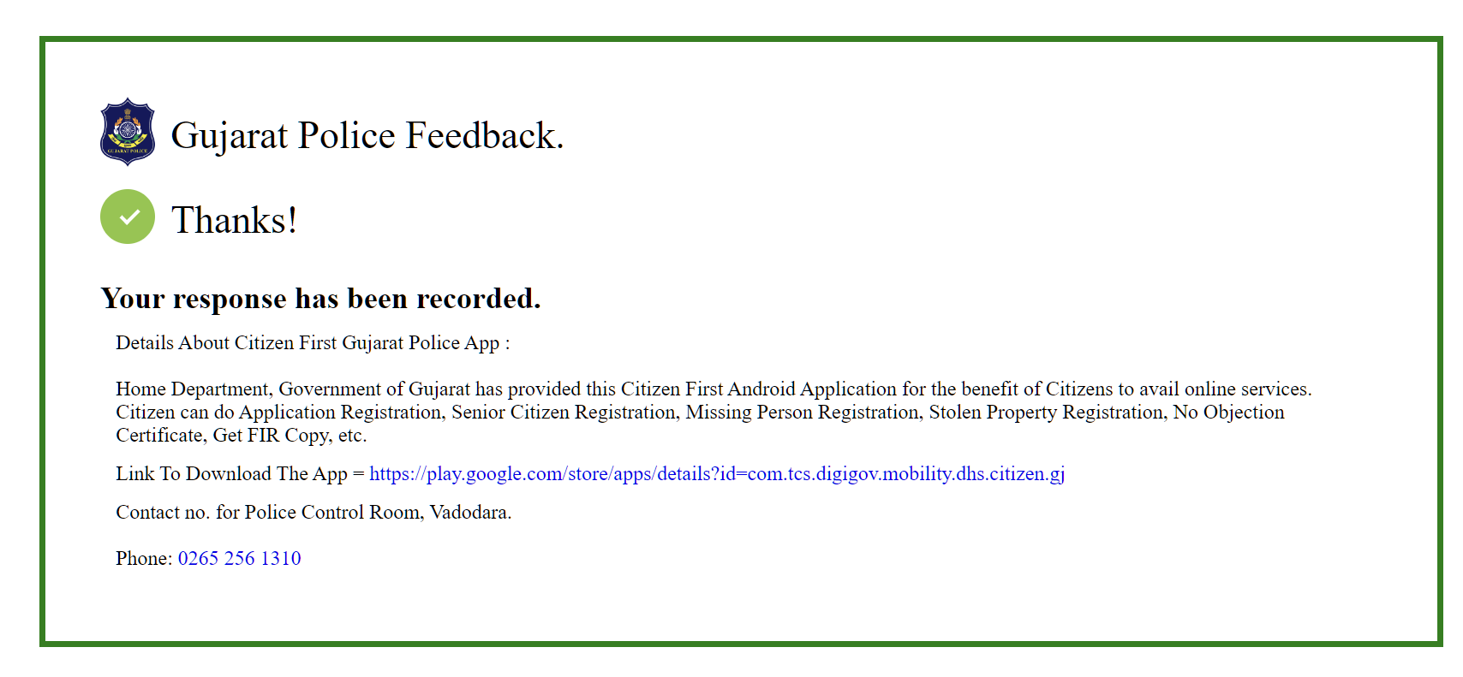

Fig. Feedback Resp

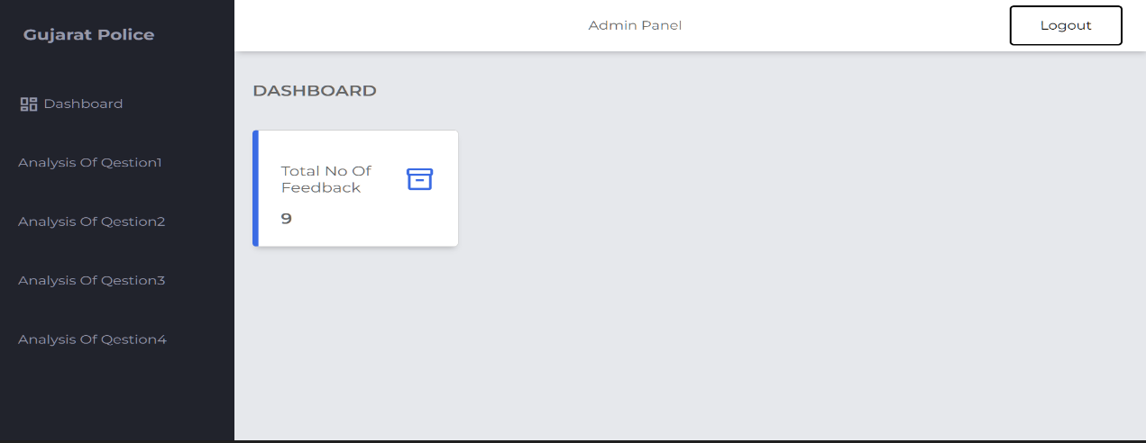

Fig. Admin Page

**5.5 List of Tables**

**Login details:**

|  |  |  |  |
| --- | --- | --- | --- |
| **Field Name** | **Data Type** | **Description** | **Example** |
| no | Int (4) | No of Question |  |
| Question1 | text | Question |  |
| Question2 | text | Question |  |
| Question3 | text | Question |  |
| Question4 | text | Question |  |

**Chapter 6 Conclusion and Discussion**

Through this feedback form police can easily identify their mistakes, so they can improve that and also citizens will get better behavior of police and faster response from police in due course of time.

**References:**

Reference has been taken from YouTube and other google website etc. Reference has also been taken from web designing and development tutorials.

Reference links:

**1) YouTube video:**

**<https://www.youtube.com/watch?v=5jYIIwm6IeI> : otp verification**

[**https://www.youtube.com/watch?v=1SnPKhCdlsU**](https://www.youtube.com/watch?v=1SnPKhCdlsU) **: learning php**